ANUSREE. P. R

AM. SC. P2CSC19011

COMPETITIVE PROGRAMMING LAB

SET 1

BUBBLE SORT

#include<iostream>

using namespace std;

int main()

{

int i, j, n, t, a[20];

cout<<"enter the number of elements";

cin>>n;

for(i=0;i<n;i++)

{

cin>>a[i];

}

for(i=0;i<n;i++)

{

for(j=0;j<n-1;j++)

{

if(a[j]>a[j+1])

{

t=a[j];

a[j]=a[j+1];

a[j+1]=t;

}

}

}

cout<<"array after sorting";

for(i=0;i<n;i++)

{

cout<<"\n"<<a[i];

}

}

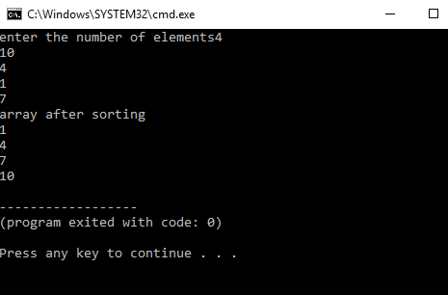

SELECTION SORT

#include<iostream>

using namespace std;

int main()

{

int i, j, t, n, min, a[20];

cout<<"enter the number of elements";

cin>>n;

cout<<"enter elements";

for(i=0;i<n;i++)

{

cin>>a[i];

}

for(i=0;i<n;i++)

{

min=i;

for(j=i+1;j<n;j++)

{

if(a[j]<a[min])

{

min=j;

}

}

t=a[i];

a[i]=a[min];

a[min]=t;

}

cout<<"array after sorting";

for(i=0;i<n;i++)

{

cout<<"\n"<<a[i];

}

}

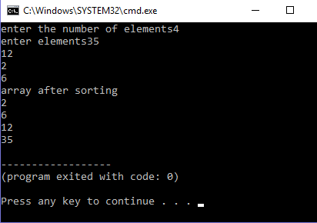

INSERTION SORT

#include<iostream>

using namespace std;

int main()

{

int i, j, k, n, t, a[20];

cout<<"enter the number of elements";

cin>>n;

cout<<"enter elements";

for(i=0;i<n;i++)

{

cin>>a[i];

}

for(i=1;i<n;i++)

{

for(j=i;j>=1;j--)

{

if(a[j]<a[j-1])

{

t=a[j];

a[j]=a[j-1];

a[j-1]=t;

}else

{

break;

}

}

}

cout<<"array after sorting";

for(i=0;i<n;i++)

{

cout<<"\n"<<a[i];

}

}

